

Ankit Varma
WhatsApp | +91 8169235673 | send2ankit@ya.ru| send2ankit@yahoo.com | Seawoods, Navi Mumbai |

WORK EXPERIENCE
Software Developer Sep 2021 – Jan 2023
Retailer Web Services (Phoenix, Arizona, U.S.A.)
» Work:
• Web crawling using Java programming language.

Robotics Intern Mar 2019 – Mar 2020
C-DAC (Kharghar, Navi Mumbai)
» Research on NLP Voice Recognition:
• Voice recognition is required for control of robot as an additional feature. Techniques for implementing this included recording of samples, removing noise using Audacity and finally training it on our algorithm.
» Research on Object Recognition:
• Object recognition is required to prevent collision of robot with its immediate environment. Techniques for implementing this included creating math for the algorithm which segregates a single attribute of an object from a set of attributes.

Front-end and Back-end Developer Intern Jan 2019 – Mar 2019
Bee'ah Sharjah Environment Co. LLC (Sharjah, UAE)
» Objective:
• Planning a strategy to overcome overflow of garbage bins and to create a single dashboard to view the current status of bins in the city.
» Implementation:
• Creating a UI and GPS enabled location tracking app for users to send the photo of bin in case of damage. An optional comment field is present to provide extra description. MongoDB is used for data storage in the backend and the app is developed using Ionic framework. It is supported on Android platform.
» Testing:
• App installation was done on different API platforms and on multiple devices to identify any potential bugs. Data transfer testing was initially done on wireless hotspot using 5 JPG images sent simultaneously each having size of 5-6 MB. The transfer took 2 second.
» Bug Removal:
• Infinite scroll bug found while uploading more than 4 images was fixed.

SKILLS
  - Languages: Core Java, Advanced Java, HTML, CSS.

PROJECTS
  - Semester 8 (Jan 2020 → Mar 2020)
    - Robotics: Floor Cleaning Robot
• A multi-functional robot that has the ability to detect 21 objects and receives commands from Web GUI.
• Built using Raspberry Pi 3 - Model B+ and a 4-wheel drive custom-designed chassis.

  - Semester 7 (Jul 2019 → Sep 2019)
    - Android Application: Computer Hardware Shop
• An Android app to order computer hardware, laptops and other tech stuff.
• Built using Android Studio with Java language and Firebase real-time database.

  - Semester 5 (Jul 2018 → Sep 2018)
    - Internet of Things: Car Collision Detection and Warning System
• An automated dashboard system in car that alerts the driver of an immediate obstacle by light indicators, warning sound and takes control of the car.
• Built using Arduino UNO R3.

    - Website: Indian Heritage
• An informative website to equip visitors with the knowledge of unique heritages of India. Viewers can send their reviews about the content and request changes. All places are
categorized based on UNESCO definition.
• Built using HTML, CSS, JavaScript, and Bootstrap.

  - Semester 3 (Jul 2017 → Sep 2017)
    - Java Application: Employee Database Management System
• An application made for employees to retrieve their info, send mail, request leave and for database administrators to manage and add new personnel.
• Built using Java Swing and Derby.

EDUCATION
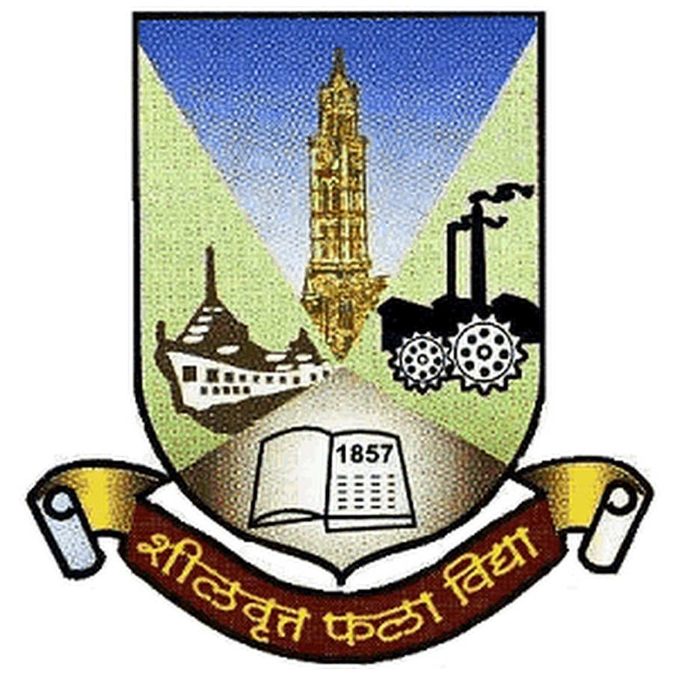
Graduate [View degree certificate] 2016 - 2020
Mumbai University, B.E. Information Technology Engineering.
Saraswati College of Engineering, Kharghar, Navi Mumbai 410210.

CGPI: 7.1
Marks Obtained: 4067/6025 (67.5%)

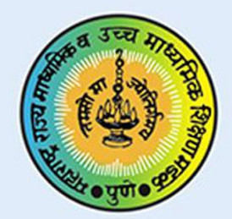
College, Science (Non-medical) [View HSC certificate] 2013 - 2015
Maharashtra State Board of Secondary and Higher Secondary Education
Marks Obtained: 425/650 (65.38%)

Schooling [View SSC certificate] 2003 - 2013
Maharashtra State Board of Secondary and Higher Secondary Education
Marks Obtained: 499/550 (90.73%)



